YAMAHA R1-2015 FULL & DECAT EXHAUST SYSTEMS
LOWER SMALL LINK PIPE PART SLIPS INTO LARGER UPPER LINK PIPE PART TO ALLOW ADJUSTMENT

USE SUPPLIED DB KILLER (GP1R) OR INSERT (GP2/GP2R) AS SHOWN BELOW FOR LOWER DB LEVELS

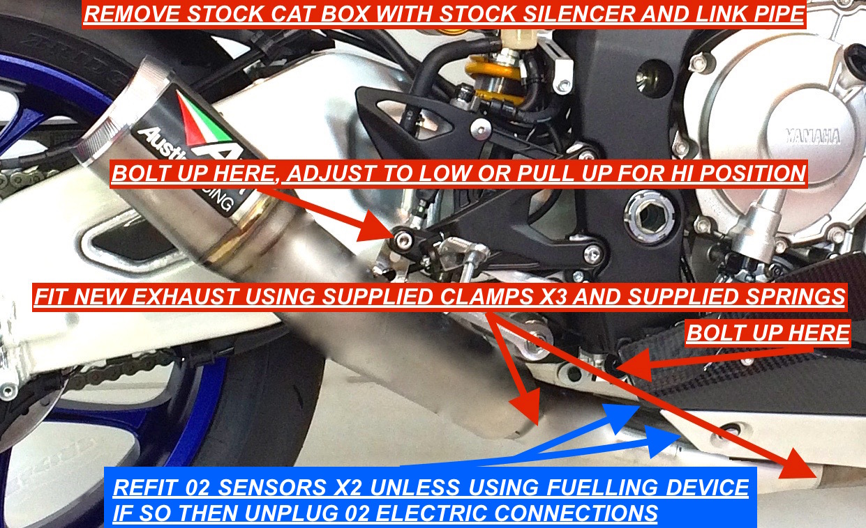
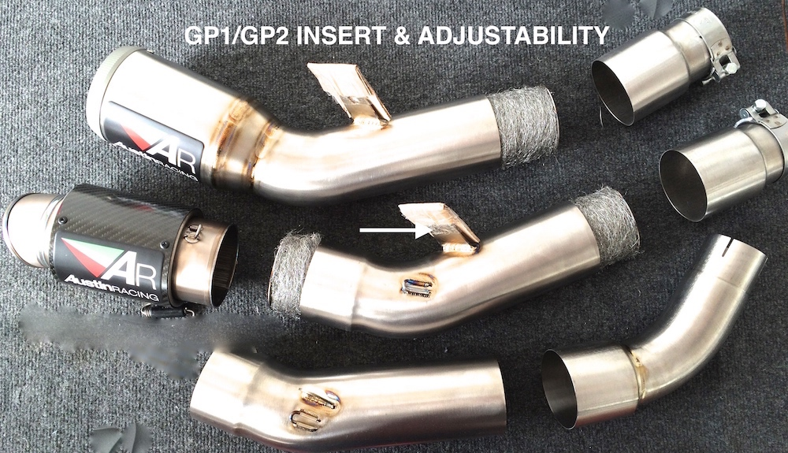
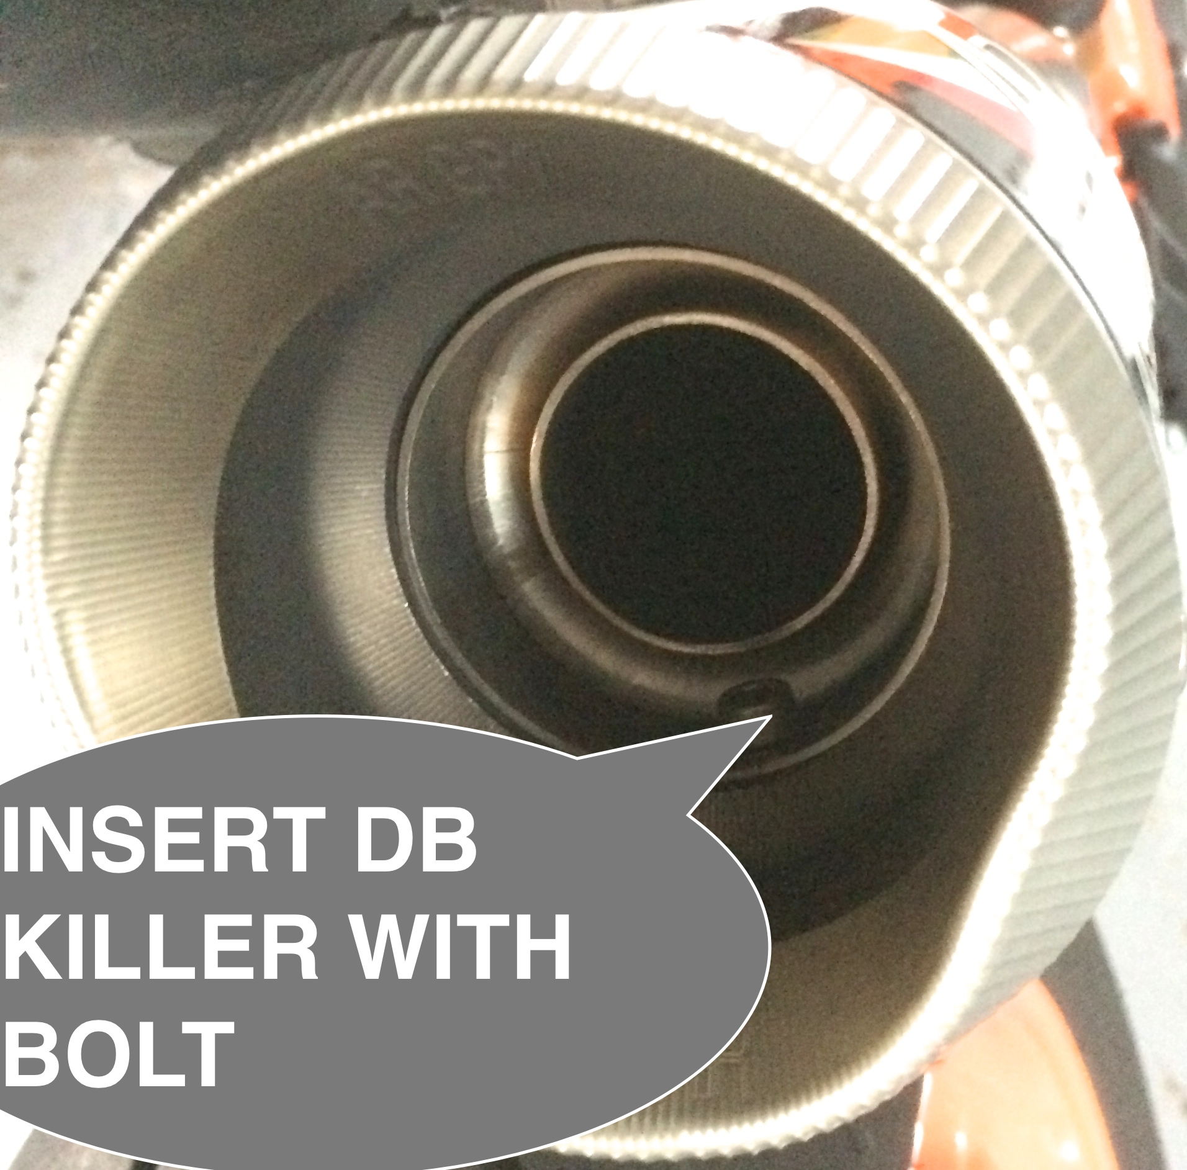
Please note the GP3 Y-Piece fixing bolt on bracket needs to be at 12 Nm torque setting so it is not over tight to allow the rubber mounting point to work correctly.
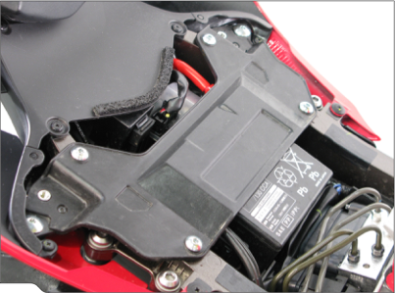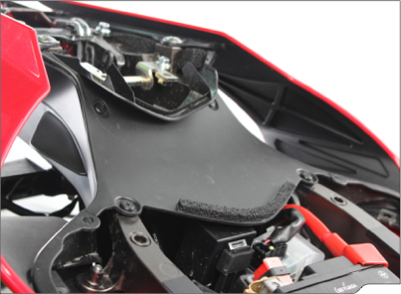

REMOVE SEAT REMOVE COVERS X2
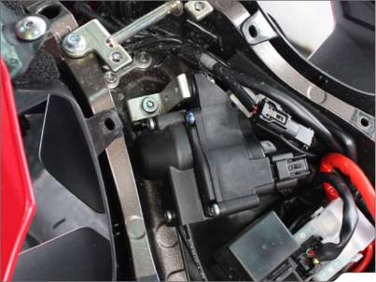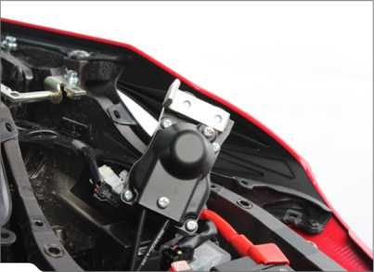

REMOVE SERVO & COVER TO EXPOSE CABLES
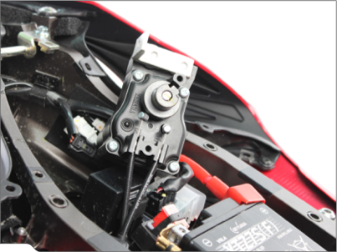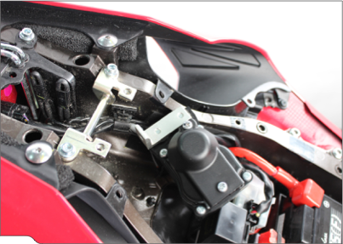

REMOVE CABLES FROM SERVO & FROM BIKE PULLING DOWN TOWARDS EXHAUST
RE FIT SERVO AND COVER. IMPORTANT LEAVE SERVO ELECTRICAL CONNECTION CONNECTED TO AVOID DASH FAULT LIGHT

