BMW S1000RR ’20 De-Cat Fitting Instructions
OEM BMW removed parts, re-used for fitting:

Foot rest exhaust hangar fasteners
Radiator bracket and fittings
Stock exhaust servo motor mounting bracket
Exhaust header retaining nuts (copper)
Stock Header (with Cat-Box cut off)
Austin Racing parts used for fitting:

Austin Racing De-Cat
1 x Servo Eliminator
1 x Spring (GP1) (2x GP3, 3x GP2)
1 x M8 lock nut & penny washer (GP1 &GP2)
2 x 73-79mm exhaust clamps
4 x exhaust clamp plates
1 x exhaust sealant tube
3 x O2 bungs

To remove stock exhaust and fit Austin Racing De-Cat:

Un-bolt and remove stock silencer. (Retain Footrest exhaust hangar fasteners)

Unbolt exhaust valve cable fittings from silencer, un-hook cables

Unbolt exhaust valve servo from beneath the rear subframe taking care to extract remote operating cables from between the frame along with it, leave metal mounting bracket in place

Fit servo eliminator in the open plug left by the removal of exhaust valve servo.

Using supplied adhesive patch and cable ties, securely mount the servo eliminator to this bracket ensuring it cannot come loose.

Remove lower side panels on each side of the bike, retain all fasteners for re-fitting. This should give you enough access to the headers for fitting. If more access is required depending on the tools being used for fitting, upper side panels may also be removed on both sides but is not necessary.

Unscrew all 4 lambda sensors from stock exhaust. Make a note of where they have been unbolted, as the lambda boss locations on your Austin Racing headers are different to stock, but the lambdas are in the same place relative to each other. (E.g front right/rear left)

Unbolt radiator bracket, pull the ends out of the rubber radiator bushings. Retain bracket and fixings for re-fitting.

At this point it is a good idea to protect your radiator so it does not get dented by a stray tool during fitting, simply cut some cardboard to a rough shape and tape in place on the inside of the radiator.

Loosen the cat box retaining fastener. You will find this under the back of the bike in front of the rear wheel attached to the anti-vibration pillow block. remove the nut, but leave the bolt in place supporting the weight of the cat box.

Un-do all but 1 of the header retaining nuts and retain for re-fitting. Loosen the remaining nut so that it is only finger tight, it is usually best to leave the outside nut on header 4 (right hand side if sitting on the bike) as this has the best access.

Supporting the exhaust (we suggest having somebody to assist you, but this is possible with one person) remove the loose cat box retaining bolt, and the final header nut.

Lower the whole exhaust assembly down and out from under the bike. Take extra care to not catch the balance tube between the headers on the lugs on the radiator, or the outer most headers on the hoses running to the radiator on either side. You may need to twist the exhaust to get one side out and under one side of the radiator hoses, and then the other. (we suggest removing the system out under the right hand side off the bike to avoid fouling the side stand etc)

Remove the pillow block that the cat box was attached to, this is not required for re-fitting.

With stock headers removed, mark up as per the example below:

Before proceeding with cut, double check your measurements and always wear the correct safety attire. We suggest safety goggles, gloves and especially a mask as the cut can create fine particles from the Catalytic Convertor core.

Cut the headers square along the line you have marked, making sure the length is equal on all sides. This can be done with a hacksaw, thin (1mm) cutting disc on an angle grinder or similar.

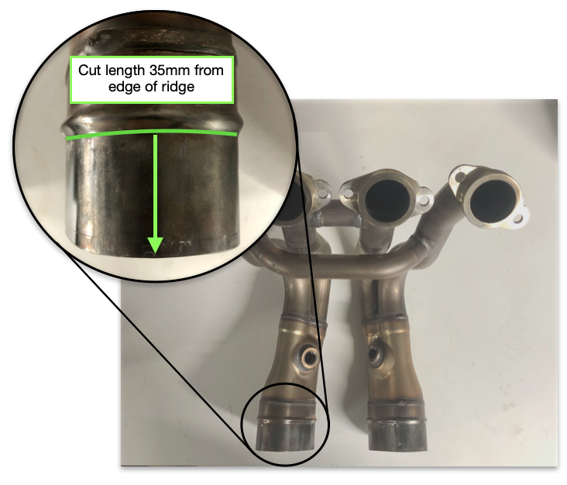
Once the headers have been cut you can remove the remains of the Catalytic Convertor core if you wish, you don’t have to if the core retains its structure. If it becomes damaged and crushed it is best to remove. This can be tricky but just takes perseverance to get it out.
BMW S1000RR ’20 De-Cat Fitting Instructions

Makes sure to fully de-burr your cut, as if you do not this can hinder fitting.

Using the original fasteners, fix your cut headers back in place on the bike, making sure to correctly tighten the fasteners.

To prepare your Austin Racing De-Cat for fitting:

Fitting clamps should have the bolt on the outside of the tube and have one clamp plate on either side of the tube on the flat area. Make sure these are loosely held in place. They can be re-positioned on initial fitting before fighting the clamps down.

Before proceeding with applying exhaust sealant check the manufacturers guide lines for correct safety equipment, we suggest at least a pair of nitrile gloves or similar.

Use the supplied exhaust sealant to apply a thick bead of sealant around the inside of each of the De-Cat inlets. You should need slightly less than half the tube each, there is extra incase you need to re-apply. Make sure to apply the bead over the slots in the De-Cat inlets. Once you have done this you need to fit to the headers before the sealant dries. See manufacturers guide lines for drying time.

To fit your Austin Racing De-Cat:

Place under the bike, and align the inlets with the outlet cuts you have made on your headers.

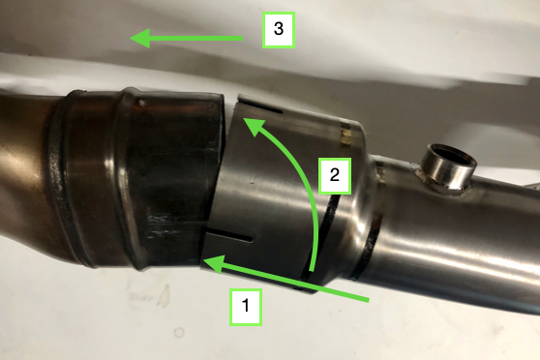
It is easiest to place the bottom edge of both De-Cat inlets over the bottom edges of the header cuts with them angled slightly downwards towards the rear of the bike. You can now push the De-Cat on whilst bringing them back up to be parallel with the header outlets. See Picture for reference:
BMW S1000RR ’20 De-Cat Fitting Instructions

You must fit both sides simultaneously. You may wish to ask somebody for help, but it can be done with just one person.

Make sure to push the De-Cat on all the way up to the ridge on the stock headers. If you do not the system may not clamp and seal properly.

If you need to, now is the time to re-adjust the clamp plates and clamps if they have moved. Once they are in the correct position, tighten the clamps down tight to seal the exhaust.

For the GP3 the rear fixing bolt hole should now line up with the frame mounting point, fit the M8 x 20mm bolt and washer finger tight so that it may still move on the mounting slot.

For GP1/GP2, slide the exhaust silencer onto the slip joint to the point that the bracket aligns with the inside face of the footrest mounting point (closest to the wheel) and securely fastening the stock fasteners.

Screw the front two lambda sensors into the headers where they came from, then screw the rear two lambda points into the two lambda bosses in your Austin Racing De-Cat on either side of the bike, taking care to make sure the cables are routed in such a way that they are not twisted and cannot come into contact with the headers at any point. The heat could damage the plastic sheathing. (You may need to re-route the cables, secure with cable ties or similar)

Remove any protection you may have used on the radiator for fitting

Re-fit the radiator mounting bracket to the radiator ensuring fixings are tight

Re-fit all the panels that have been removed.

Make sure all bolts and fixings are tight and firmly attached (for the GP3 it is advisable to thread lock the rear M8 x 20mm bolt.)

*You must now let the exhaust sealant dry as per the manufacturers instructions before starting the bike. This can take up to 24 hours*

Important information before starting the bike:

This system once installed will cause the bike to idle rough on cold start up and will likely cut out, the bike needs to be left to run so that that the ECU can re-learn the throttle trims for the new system.

The procedure is as follows,

Start bike, allow to run, let bike cut out, press start button again and repeat this until the ECU learns the new throttle trims, this should be around 2-3 restarts. You will then hear the bike tone change distinctively and at this point the bike has learnt the correct short term throttle trims and is safe to use. You may find that it can take longer than expected for the ECU to convert the short term throttle trims to learned long term default throttle trims. We have worked with BMW themselves and they have confirmed that this is how the bike can run, until it has learned these new perimeters. The longer and more the bike is ridden the better it will run. Alternatively a custom map or fuelling device can be used to overwrite the original ECU. As the learning process of the bike’s ECU for a new system causes no harm to the bike and retains the stock ECU this is what we recommend. We hold no responsibility for the use of your Austin Racing system in conjunction with any aftermarket fuelling device or ECU flash.

For GP1/GP2 systems: Your Austin Racing exhaust can be tuned for sound and power by utilising the provided link pipe inserts. Use the smaller 50mm insert if you want a quieter exhaust note, use the 60mm insert if you are running stock ECU as we’ve found this makes the best power, remove all inserts if you want the exhaust as loud as possible/ are running an aftermarket ECU flash or fuelling device for maximum power gain.

Austin Racing accepts no responsibility/liability for for any problem or accident caused by incorrect fitting or improper use.

