BMW S1000RR ’20 Full System Fitting Instructions
OEM BMW removed parts, re-used for fitting:

Foot rest exhaust hangar fasteners
Radiator bracket and fittings
Stock exhaust servo motor mounting bracket
Exhaust header retaining nuts (copper)
Austin Racing parts used for fitting:

Austin Racing Headers
7 x springs (+1 for GP3 variant +3 for GP2 variant)
1 x M8 x 20mm cap screw with washer (GP3 only)
5 x Lambda bungs
1x Servo Eliminiator
1 x M8 lock nut & penny washer (GP1 &GP2)

To remove stock exhaust and fit Austin Racing Headers:

Un-bolt and remove stock silencer. (Retain Footrest exhaust hangar fasteners)

Unbolt exhaust valve cable fittings from silencer, un-hook cables

Unbolt exhaust valve servo from beneath the rear subframe taking care to extract remote operating cables from between the frame along with it, leave metal mounting bracket in place

Fit servo eliminator in the open plug left by the removal of exhaust valve servo.

Using supplied adhesive patch and cable ties, securely mount the servo eliminator to this bracket ensuring it cannot come loose.

Remove lower side panels on each side of the bike, retain all fasteners for re-fitting. This should give you enough access to the headers for fitting. If more access is required depending on the tools being used for fitting, upper side panels may also be removed on both sides but is not necessary.

Unscrew all 4 lambda sensors from stock exhaust. Make a note of where they have been unbolted, as the lambda boss locations on your Austin Racing headers are different to stock, but the lambdas are in the same place relative to each other. (E.g front right/rear left)

Unbolt radiator bracket, pull the ends out of the rubber radiator bushings. Retain bracket and fixings for re-fitting.

At this point it is a good idea to protect your radiator so it does not get dented by a stray tool during fitting, simply cut some cardboard to a rough shape and tape in place on the inside of the radiator.

Loosen the cat box retaining fastener. You will find this under the back of the bike in front of the rear wheel attached to the anti-vibration pillow block. remove the nut, but leave the bolt in place supporting the weight of the cat box.

Un-do all but 1 of the header retaining nuts and retain for re-fitting. Loosen the remaining nut so that it is only finger tight, it is usually best to leave the outside nut on header 4 (right hand side if sitting on the bike) as this has the best access.

Supporting the exhaust (we suggest having somebody to assist you, but this is possible with one person) remove the loose cat box retaining bolt, and the final header nut.

Lower the whole exhaust assembly down and out from under the bike. Take extra care to not catch the balance tube between the headers on the lugs on the radiator, or the outer most headers on the hoses running to the radiator on either side. You may need to twist the exhaust to get one side out and under one side of the radiator hoses, and then the other. (we suggest removing the system out under the right hand side off the bike to avoid fouling the side stand etc)

Remove the pillow block that the cat box was attached to, this is not required fo re-fitting.

Take the central headers (2 & 3) and with the balance tube engaged fit them to the middle exhaust ports, affixing with 4x copper retaining nuts until finger tight. Do not firmly tighten these nuts at this point.
BMW S1000RR ’20 Full System Fitting Instructions
Fit the remaining outside headers (1 & 4) in the same way, and position the outlets so they are roughly the correct distance apart to fit the secondary collectors (they should angle inwards and create a V shape if looking from the front or rear of the bike.

Take the two secondary collectors and fit into the final collector, twist the pipes so that they make the same V shape as the front headers and are parallel to each other, then push the whole rear collector assembly onto the front headers under the bike. It’s best to do this with no springs fitted as this gives you more room to adjust.

This can be fiddly, but you do not need to use a hammer to fit any part of the headers, if you need to, something has not been aligned correctly. Twist and re-position until the everything can push together. This needs to be done equally and at the same time on both sides.

For the GP3 the rear fixing bolt hole should now line up with the frame mounting point, fit the M8 x 20mm bolt and washer finger tight so that it may still move on the mounting slot.

For GP1/GP2, slide the exhaust silencer onto the slip joint to the point that the bracket aligns with the inside face of the footrest mounting point (closest to the wheel)
*Please see next page for Important information before starting the bike for the first time*

Using the original fasteners, fix the exhaust silencer making sure only finger tight.

Fit all springs to the system, making sure that each connection is correctly bedded in as you go.
Securely fasten all 4 header nuts.

For GP3 securely fasten M8x 20mm to hold the headers in place (this may be adjusted to aid exhaust silencer fitment.

For GP1 securely fasten the footrest mounting bolt to the inside of the footrest mounting point.

The lambda point on the final collector is for tuning purposes. If you do not need this, leave the bung in place, making sure it is securely tightened.

Screw the rear two lambda sensors into the rear two lambda bosses on either side the bike.

Screw the front two lambda sensors into the front two lambda bosses on either side of the bike, taking care to make sure the cables are routed in such a way that they are not twisted and cannot come into contact with the headers at any point. The heat could damage the plastic sheathing. (You may need to re-route the cables, secure with cable ties or similar)

Remove any protection you may have used on the radiator for fitting

Re-fit the radiator mounting bracket to the radiator ensuring fixings are tight

Re-fit all the panels that have been removed.

Make sure all bolts and fixings are tight and firmly attached (for the GP3 it is advisable to thread lock the rear M8 x 20mm bolt.)

BMW S1000RR ’20 Full System Fitting Instructions
Important information before starting the bike:

This system once installed will cause the bike to idle rough on cold start up and will likely cut out, the bike needs to be left to run so that that the ECU can re-learn the throttle trims for the new system.

The procedure is as follows,

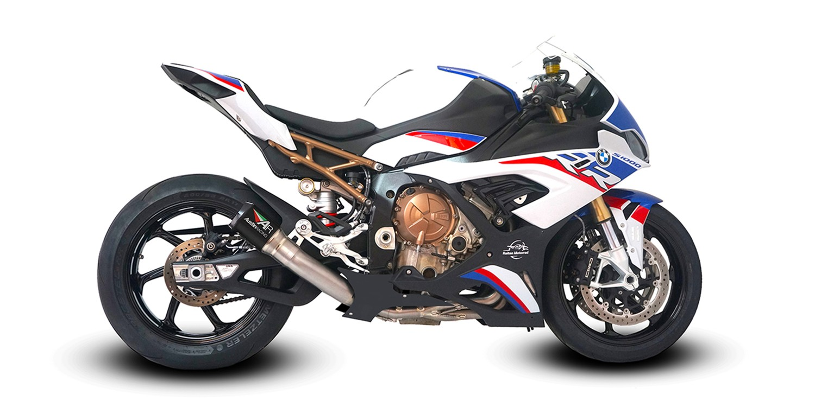
Start bike, allow to run, let bike cut out, press start button again and repeat this until the ECU learns the new throttle trims, this should be around 2-3 restarts. You will then hear the bike tone change distinctively and at this point the bike has learnt the correct short term throttle trims and is safe to use. You may find that it can take longer than expected for the ECU to convert the short term throttle trims to learned long term default throttle trims. We have worked with BMW themselves and they have confirmed that this is how the bike can run, until it has learned these new perimeters. The longer and more the bike is ridden the better it will run. Alternatively a custom map or fuelling device can be used to overwrite the original ECU. As the learning process of the bike’s ECU for a new system causes no harm to the bike and retains the stock ECU this is what we recommend. We hold no responsibility for the use of your Austin Racing system in conjunction with any aftermarket fuelling device or ECU flash.

For GP1/GP2 systems: Your Austin Racing exhaust can be tuned for sound and power by utilising the provided link pipe inserts. Use the smaller 50mm insert if you want a quieter exhaust note, use the 60mm insert if you are running stock ECU as we’ve found this makes the best power, remove all inserts if you want the exhaust as loud as possible/ are running an aftermarket ECU flash or fuelling device for maximum power gain.

Austin Racing accepts no responsibility/liability for for any problem or accident caused by incorrect fitting or improper use.

